BY:- Syed Asadullah

Supplier update

Inbound

Integration document.

1……………………………………………… What Supplier Update Inbound Integration

2……………………………………………………About this Document

3………………………………………………..Creating the Rest Connection.

4………………………………………………..Creating the FTP Connection.

5……………………………………………..…Create Integration.

6………………………………………………...Storing the Success File.

7…………………………………………………. Storing the Error File.

Supplier Inbound Integration is the automated process of importing supplier data into Oracle Fusion from external systems, such as third-party applications or legacy ERPs.
Supplier Update refers to the process of modifying existing supplier information in Oracle Fusion Applications, such as updating contact details, addresses, bank accounts, tax information, business classifications, or payment terms.
- Update existing supplier profiles
This document outlines the design and implementation of the Supplier Update Inbound Integration between an external system and Oracle Fusion Cloud ERP, using Oracle Integration Cloud (OIC). The purpose of this integration is to automatically update supplier in Oracle Fusion by processing data received in a CSV file format from an external source via SFTP.

•The functional and technical scope of the integration
•Details on input file format and location
•Step-by-step explanation of the integration flow
•Configuration of connections (REST and FTP)
•Data transformation and business logic used
•API details for supplier update operations

This integration plays a key role in maintaining consistent and automated supplier master data updates across systems and supports scenarios such as data synchronization, data marking for test cycles, or enrichment of supplier information.
- Creating the Connections
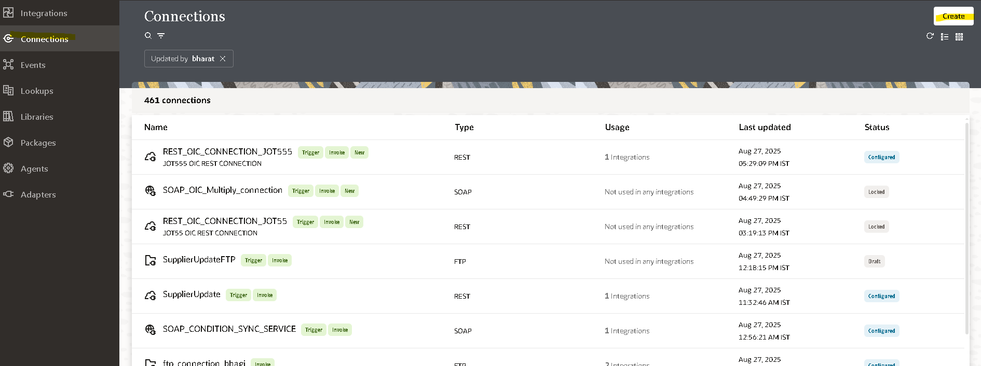
Click on the create button search for the connection which you want to create.
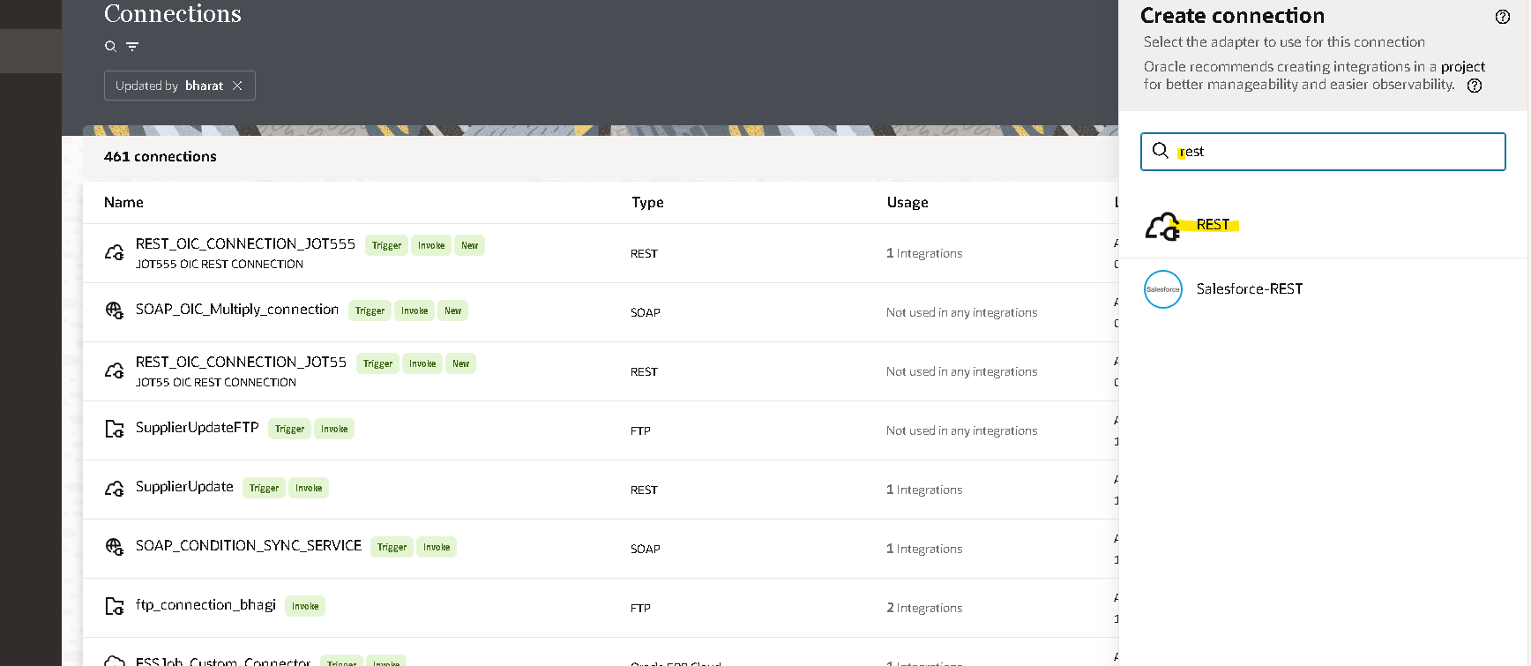
Give the URL of your rest connection {https://fa-epxp-test-saasfaprod1.fa.ocs.oraclecloud.com/}
And also the authentication for it, which will be same as the fusion .
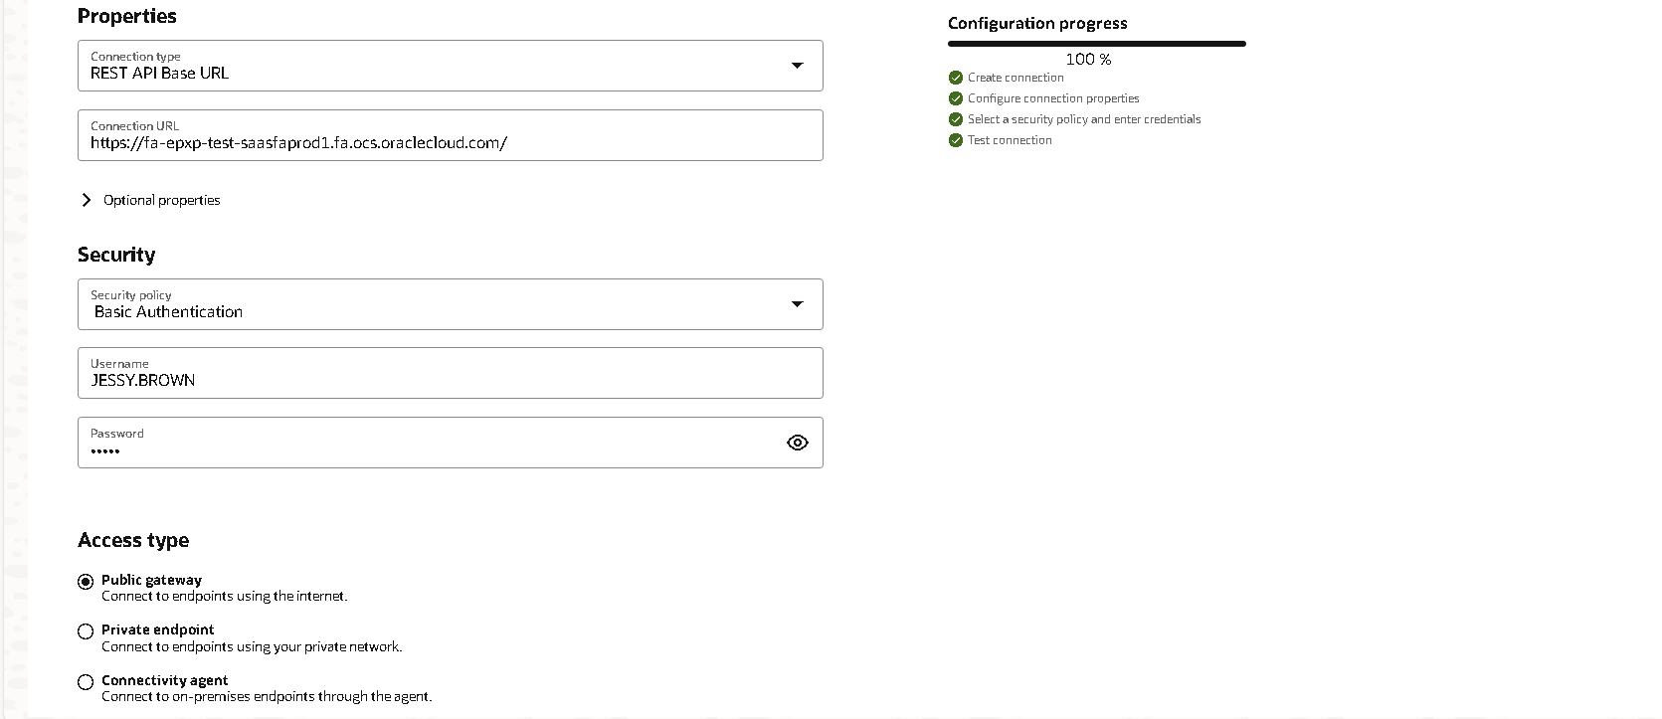

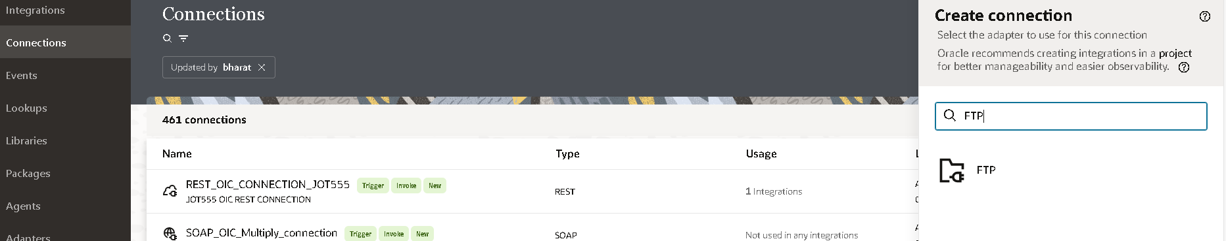
Give all the login credentials
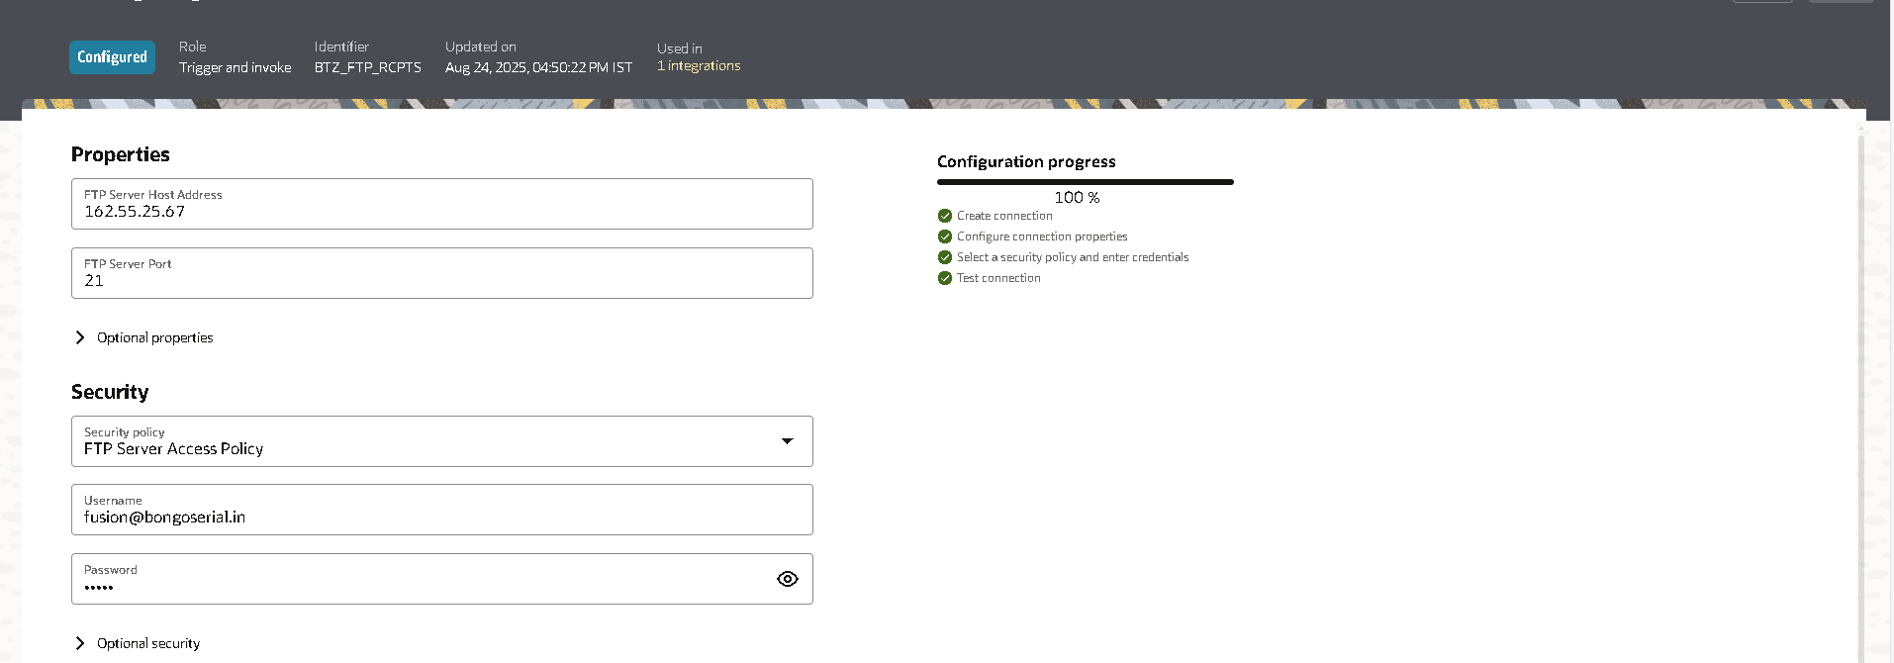
And save it after testing.

- Create integration
In integration tab click on create
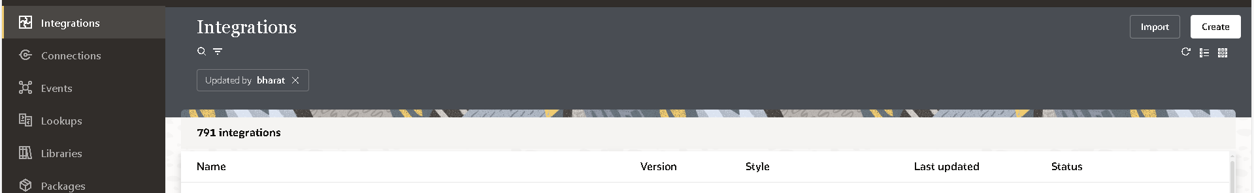
Provide the integration Name and enter into it.
By clicking on + icon select the rest connection which you have created.
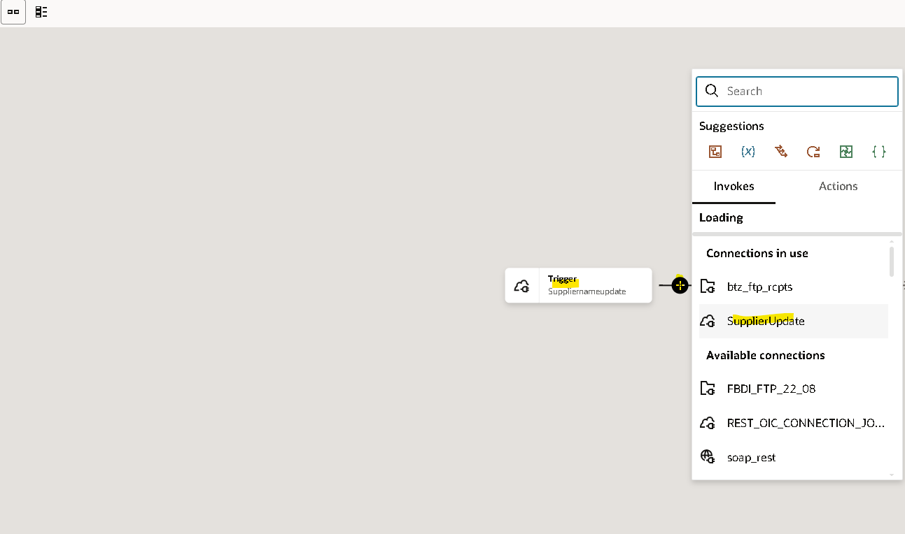
Inside it define your endpoint.
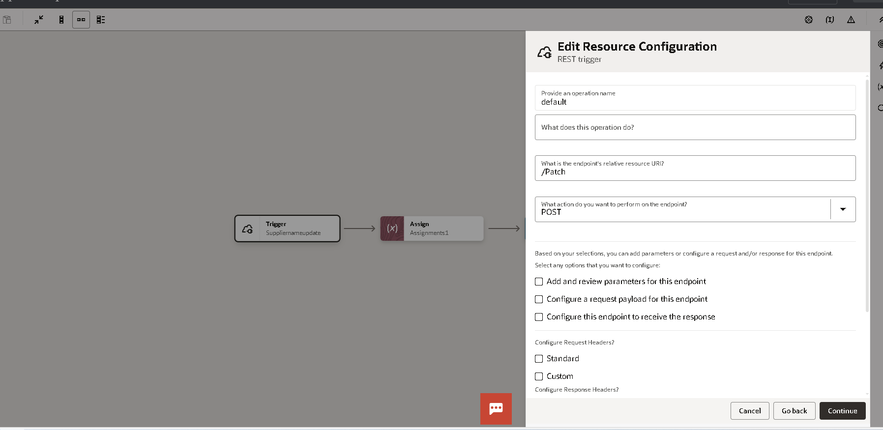
We are assigning a variable to the directory where the CSV file is stored to simplify the mapping process in the Node Mapper.
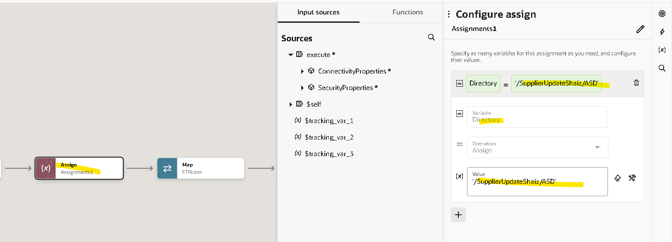
Now by clicking on + icon we have to add the FTP connection which we have created.
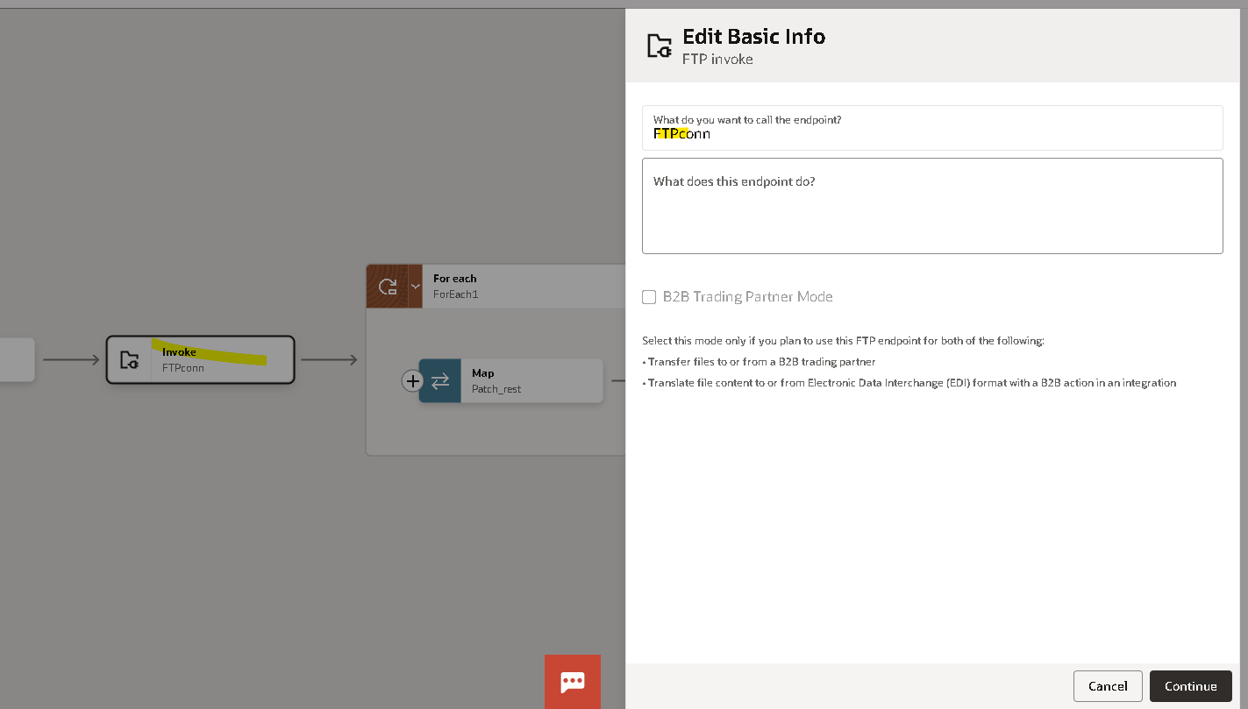
Give name to this endpoint
- Select Operation
- Directory
And file name which you have stored in the SFTP server
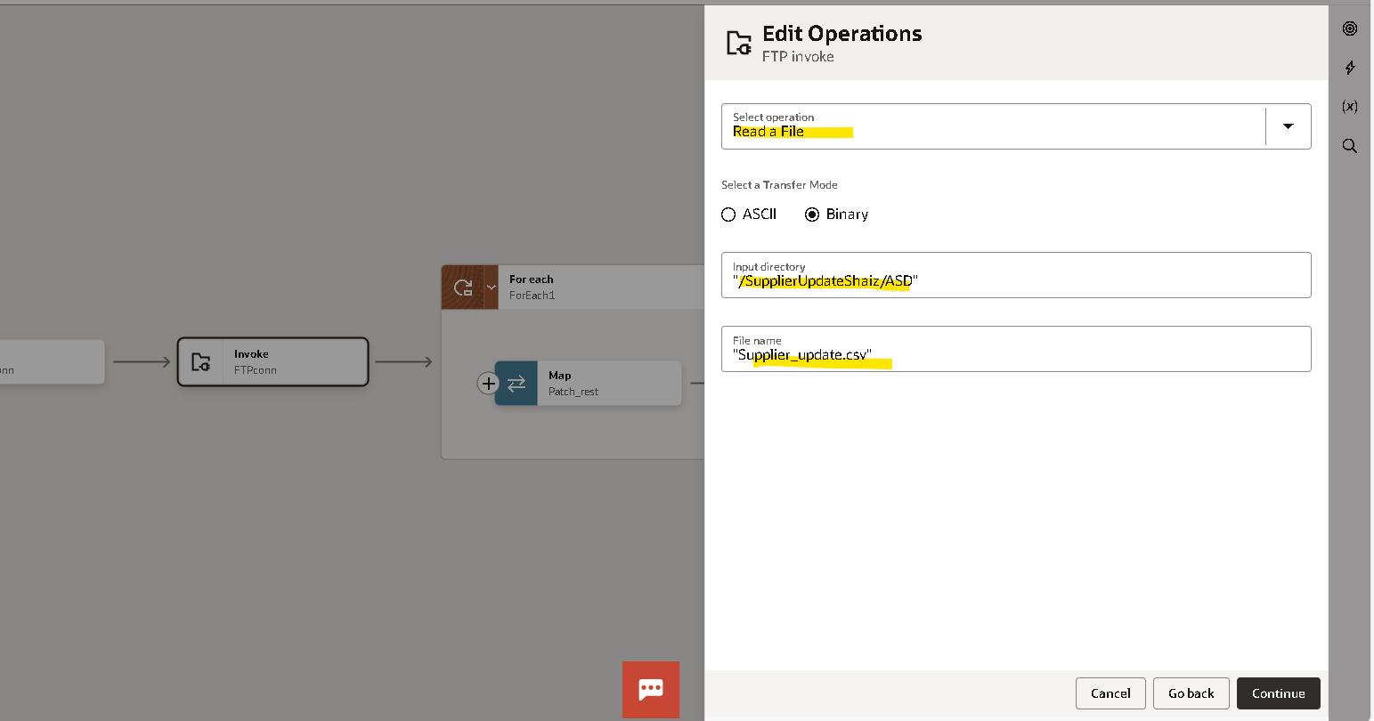
Click on continue.
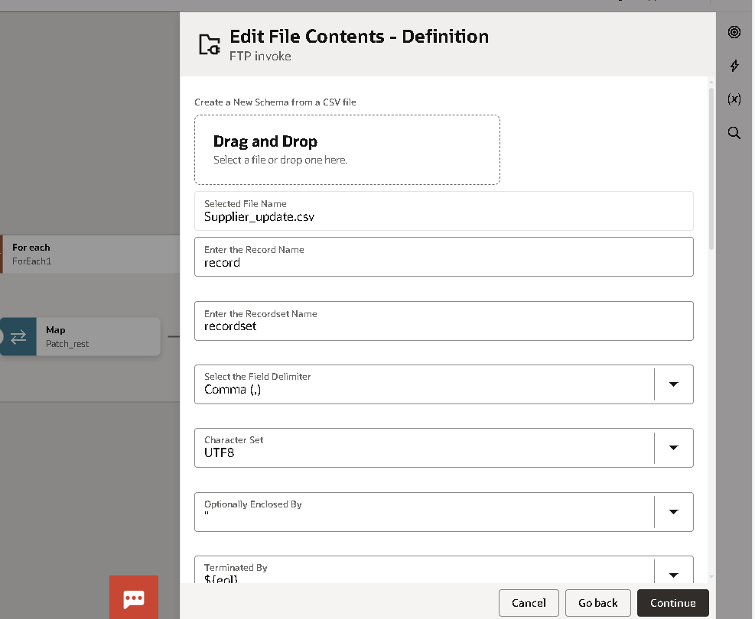
Drop the example of that CSV SFTP file here

I have used this data to update.
If you roll down on the same page you will find the data of that CSV file
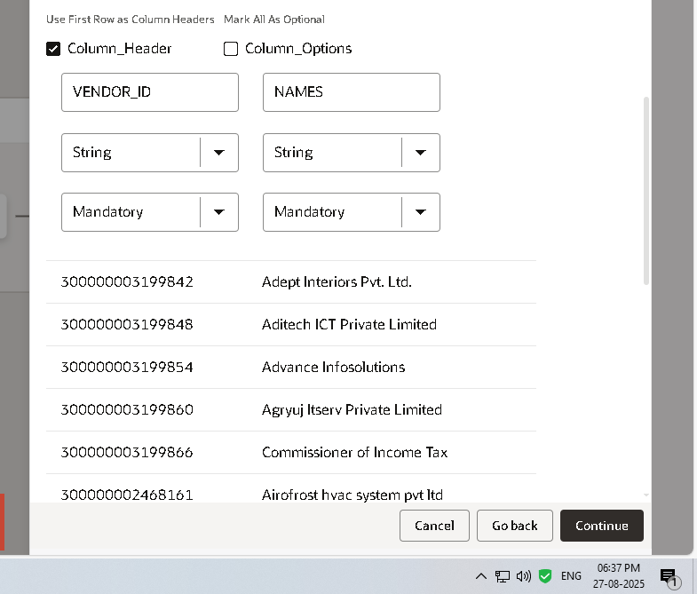

Open the Mapper of the FTP connection
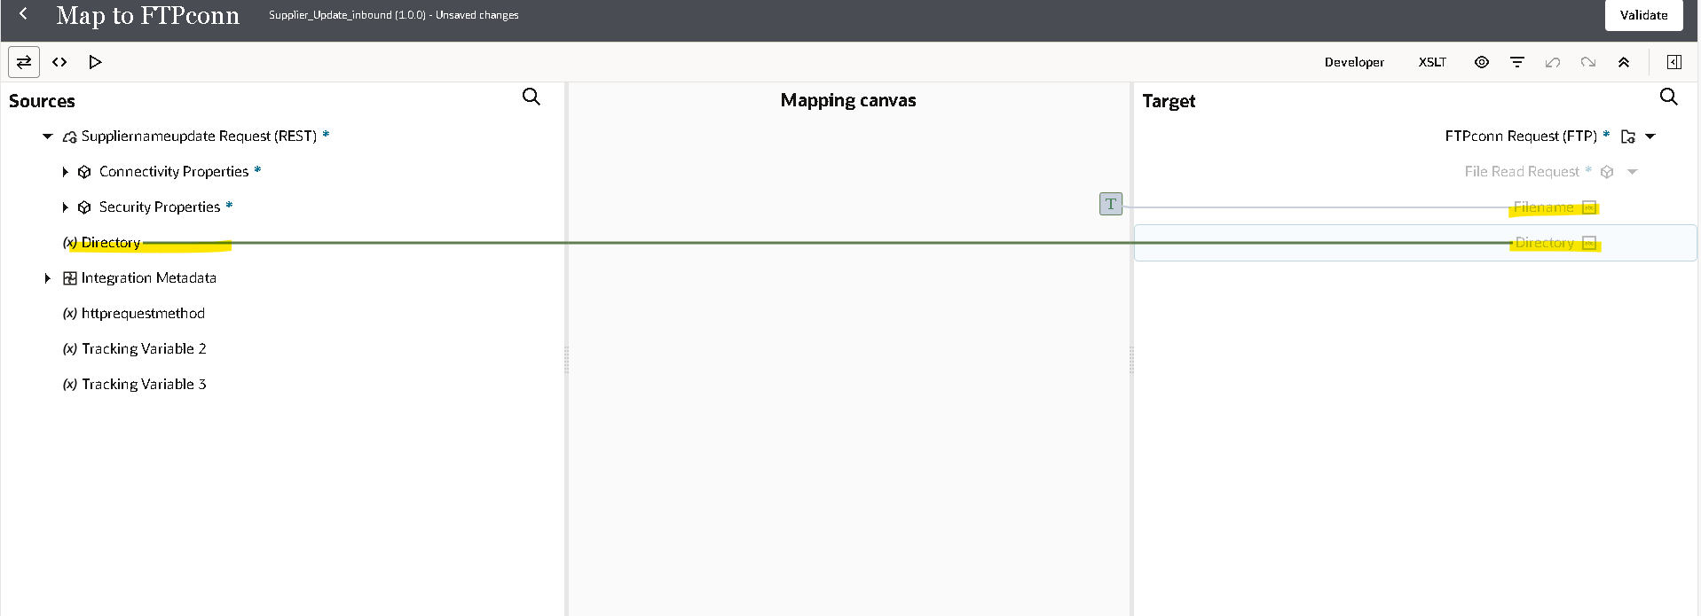
Map the Directory with the variable which you have created.
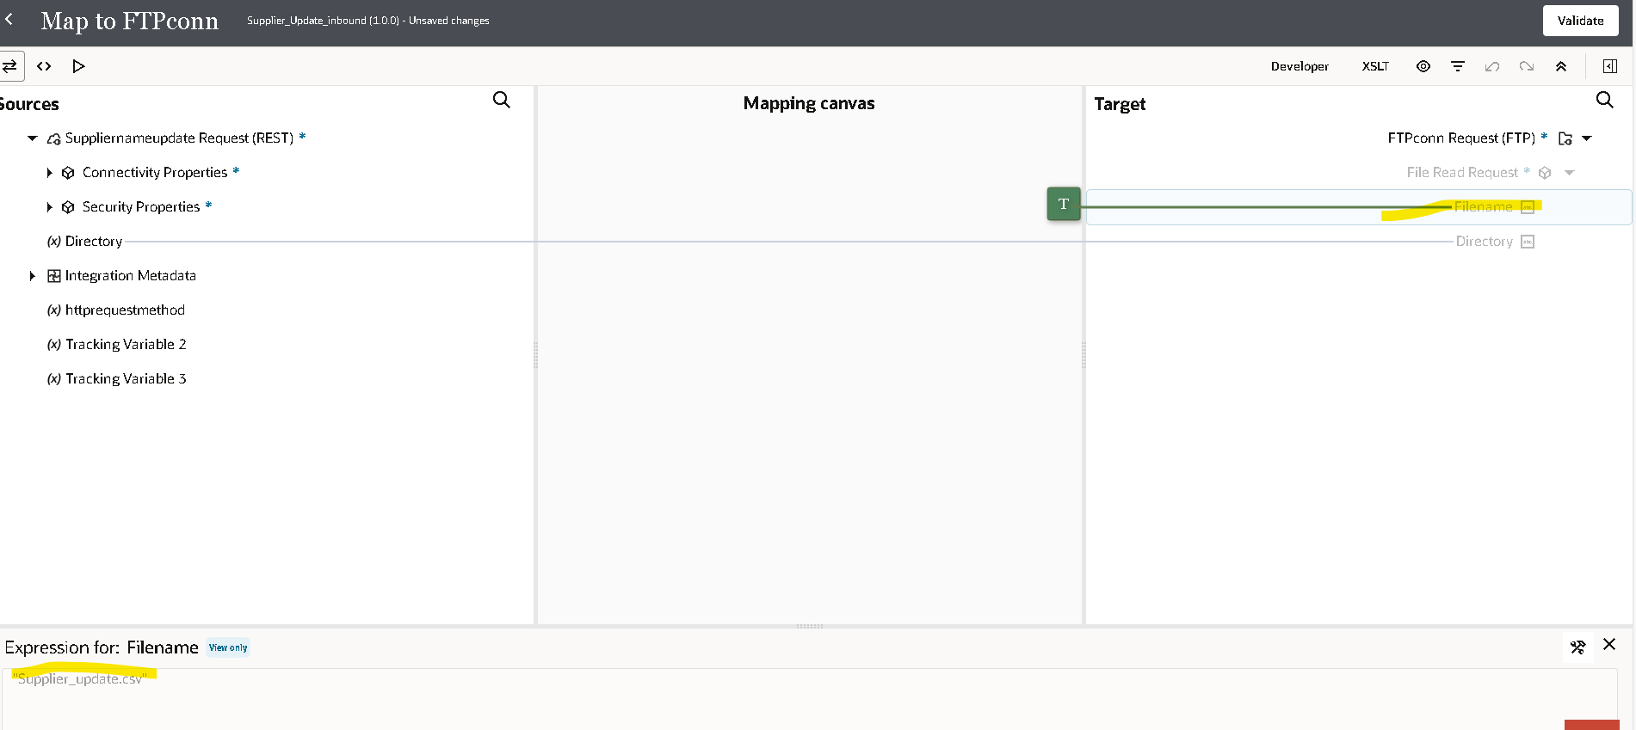
Add the file name of the CSV.

Click on the + icon and select FOR EACH
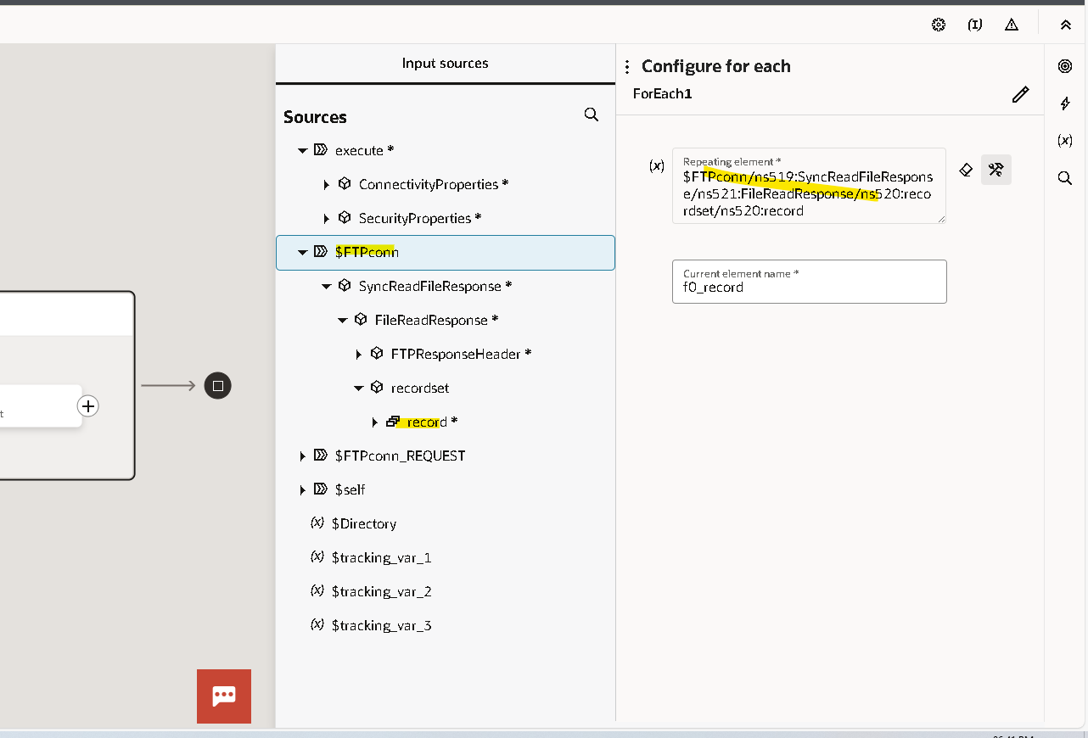
In for each give the FTP file repeating element to it.
Inside it we have to create the Rest connection
For PATCH
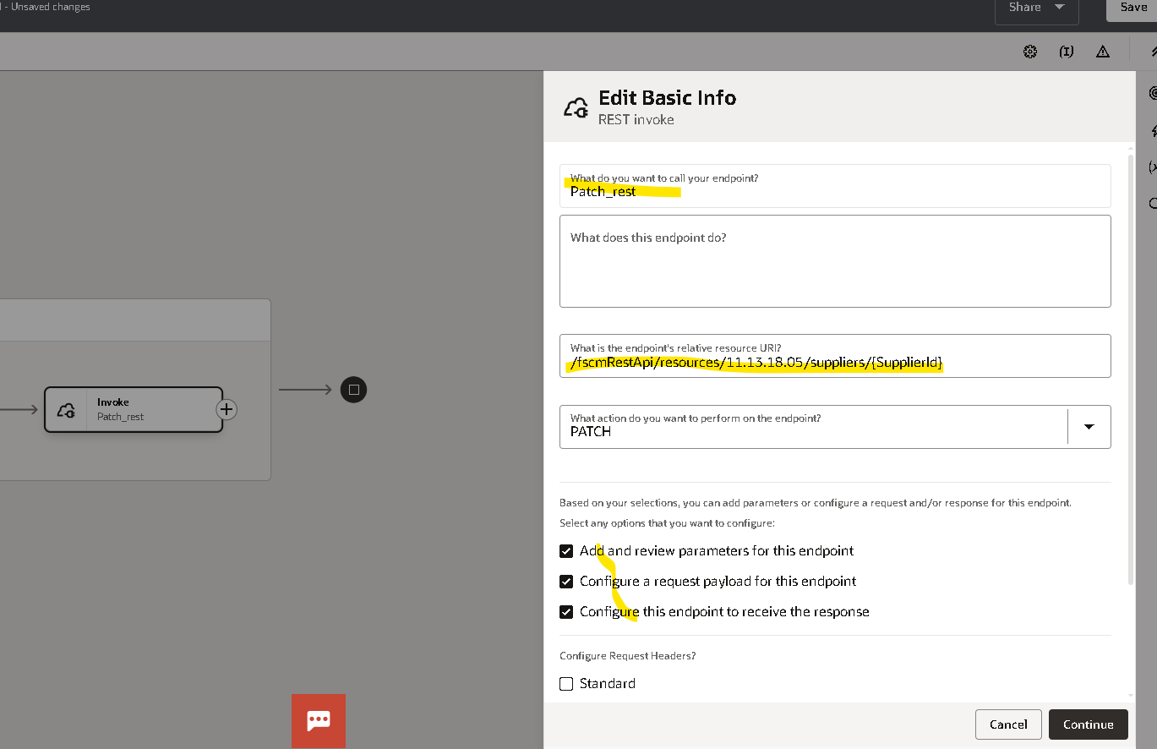
Give the REST API URL
- The end point.
- The input payload.
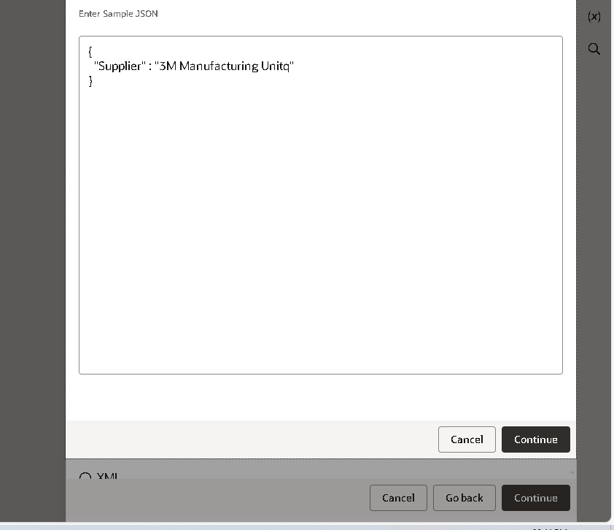
Click on continue and give the Payload response.
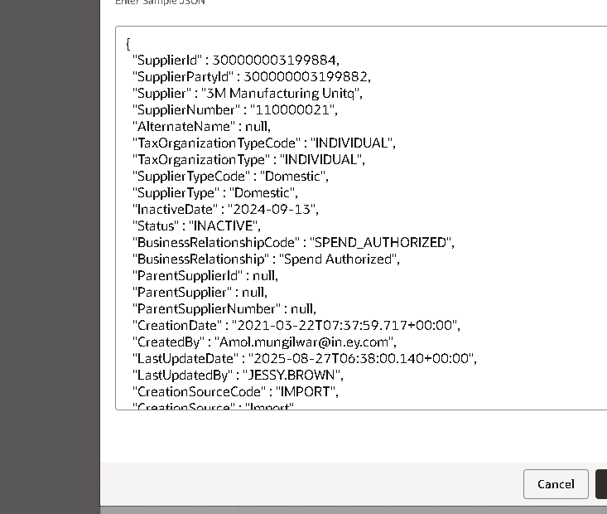

Click on Continue and Finish
Open the mapper of the Rest connection.
Map the supplier ID and the Supplier name.
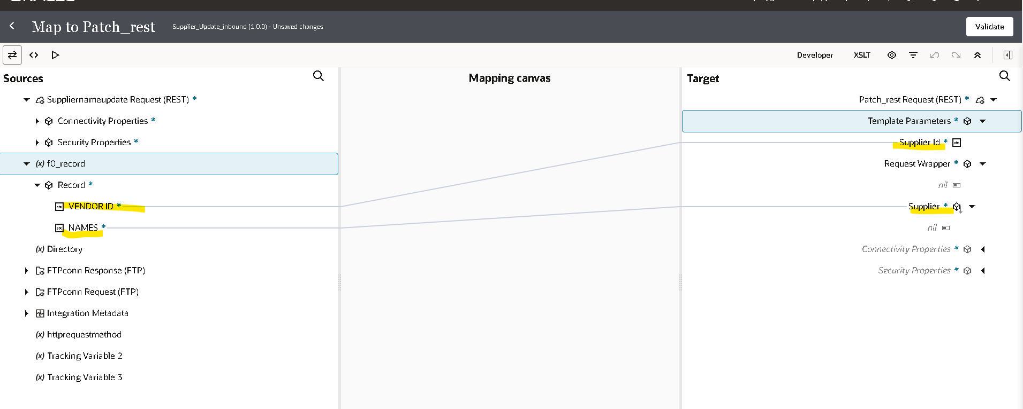
3. Storing success file.
By using an FTP connection, we can store the success file on an SFTP server. 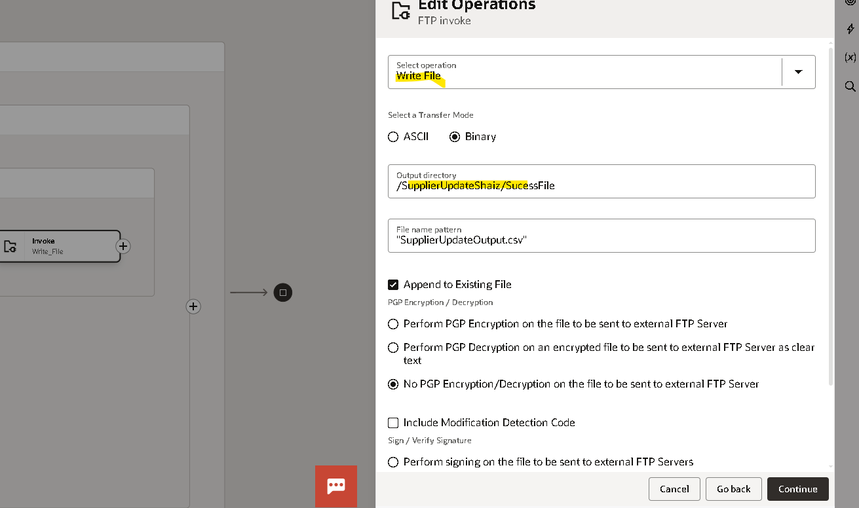
Select Operation as write file

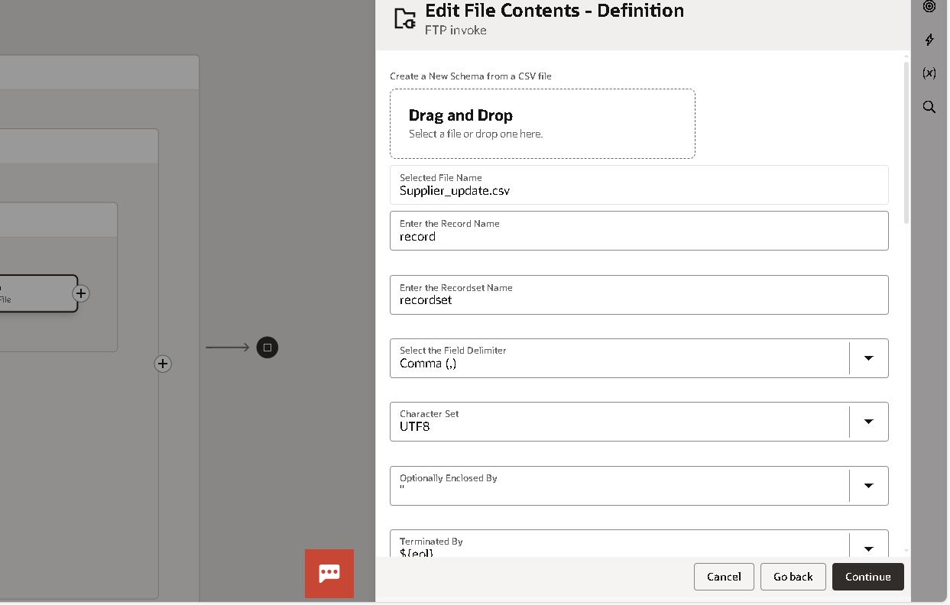
Give any sample file

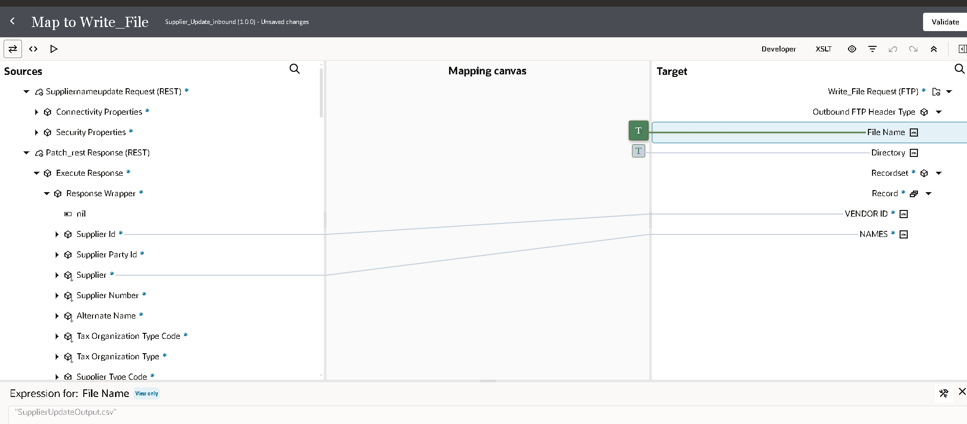
In mapper Give A file name from which you want to store the file.
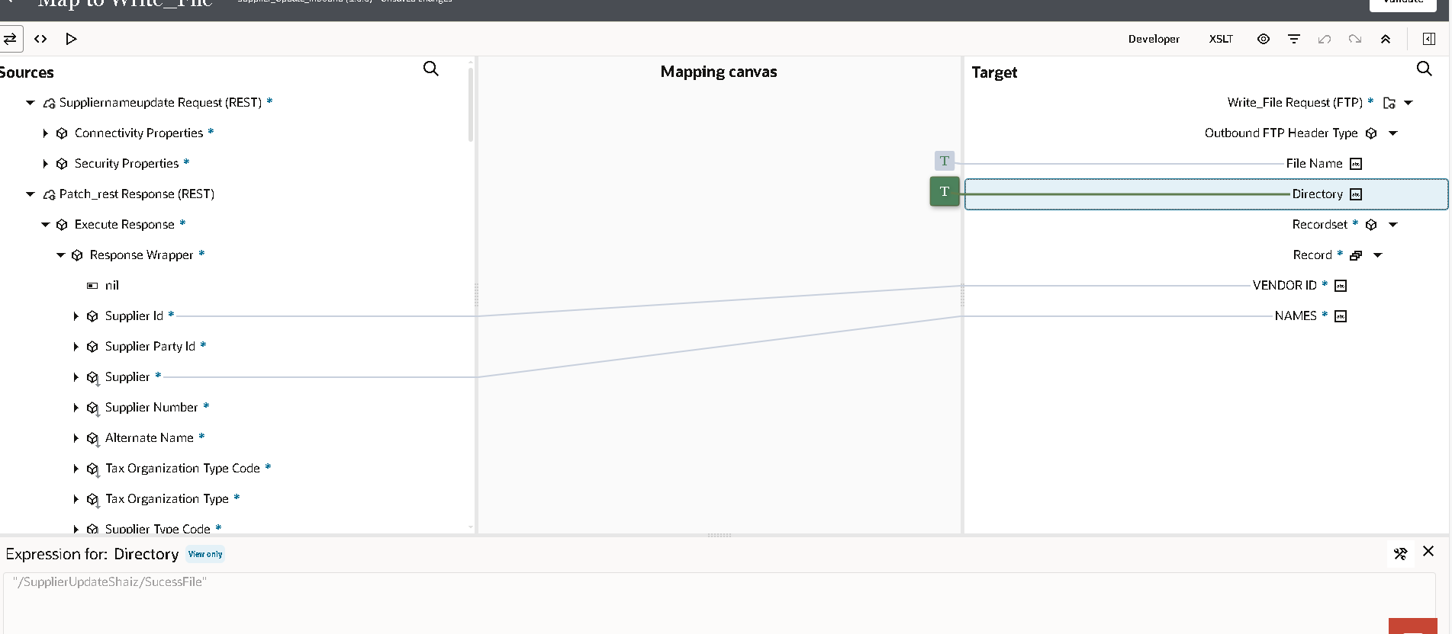And where you want to store the success file.

Fault Handler.
By using a fault handler, we can store the error log to identify the type of error we are facing.
By Using a fault handler allows us to log errors and analyse the type of error encountered.
By using the same method as we used to store success file in the SFTP server through FTP.

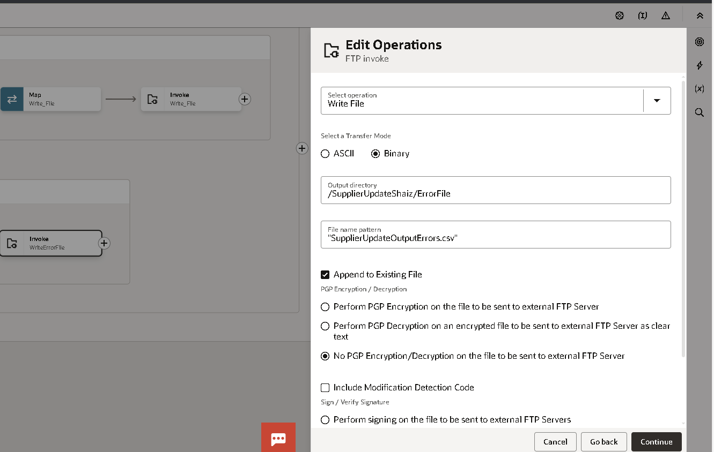

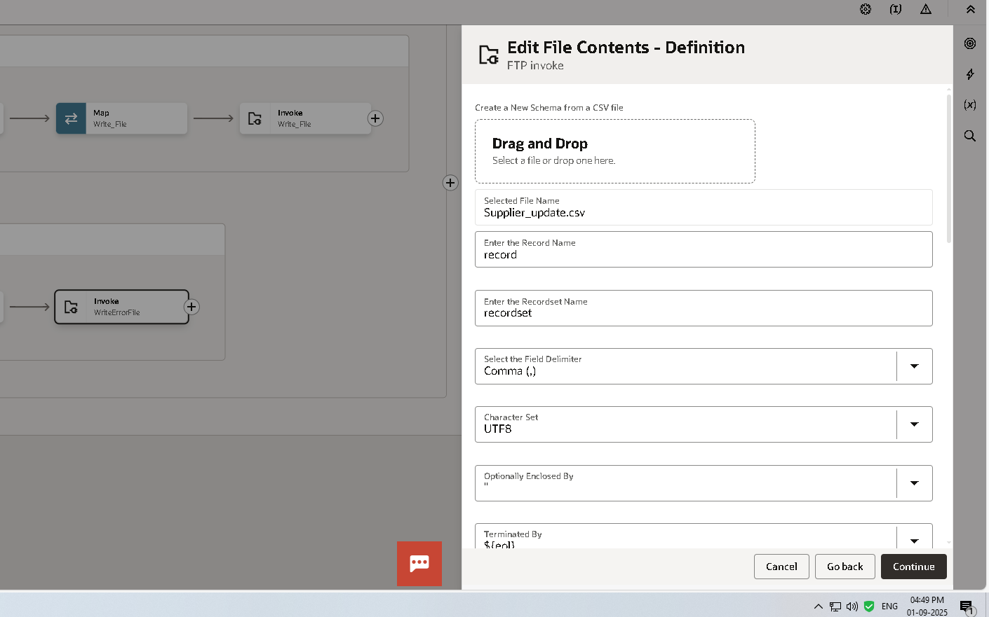
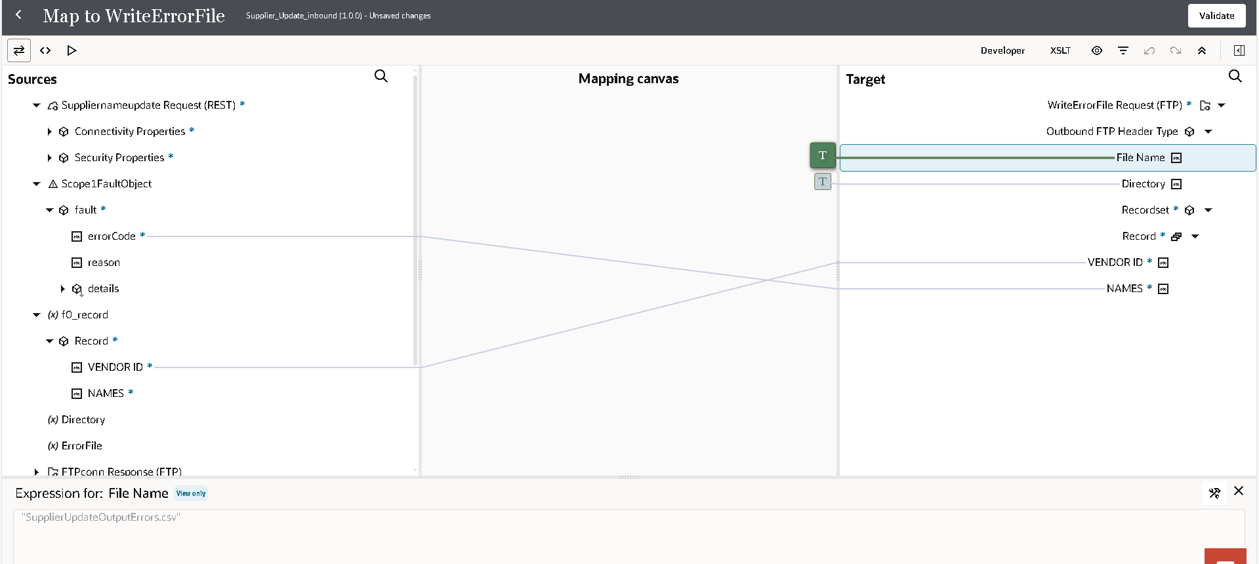
In this mapper, the error code we have mapped will indicate the error in the file.
You can find the integration from below file.

